**CSC 555 Phase 1**

**Yiyang Yang**

**Part 1**

Nodes status screenshot.

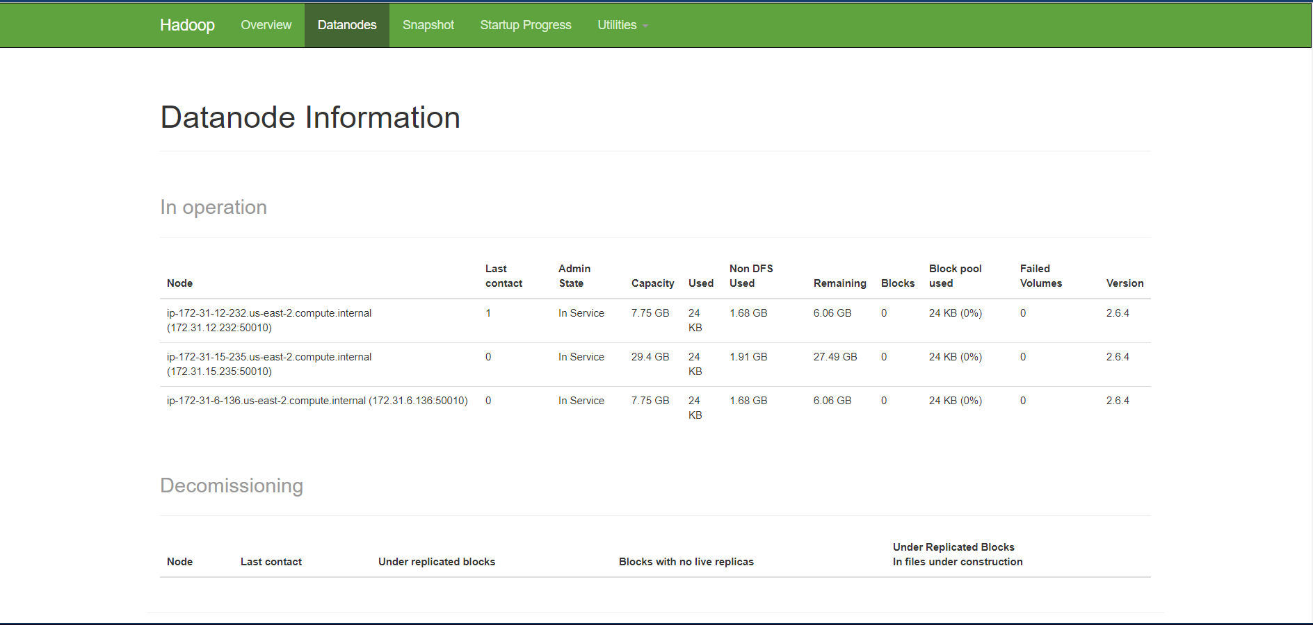

Word count time.

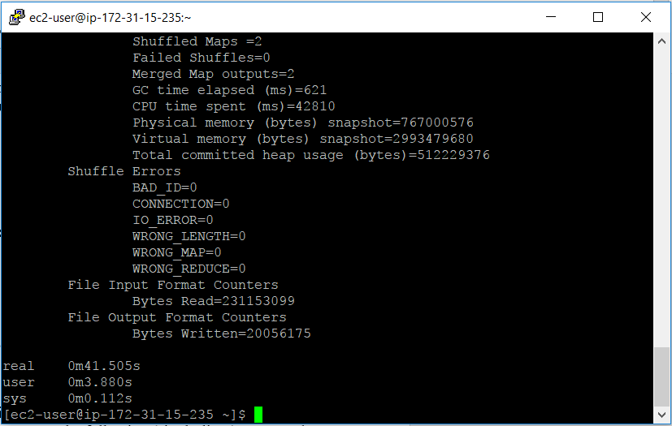

**Part 2**

**1.1**

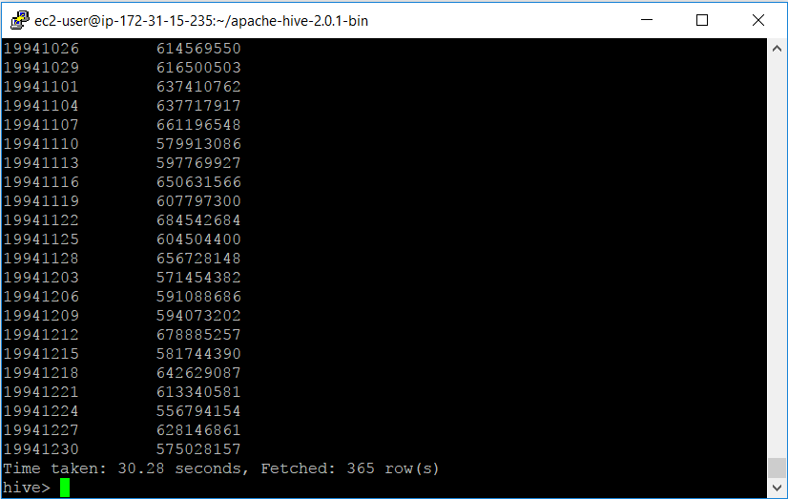The runtime is 30.28 seconds

**1.2**

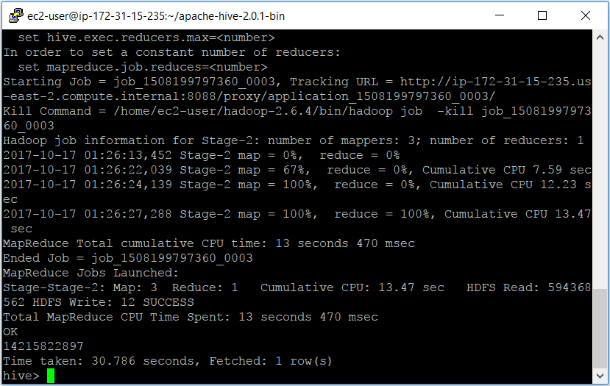

The run time is 30.786 seconds.

**1.3**

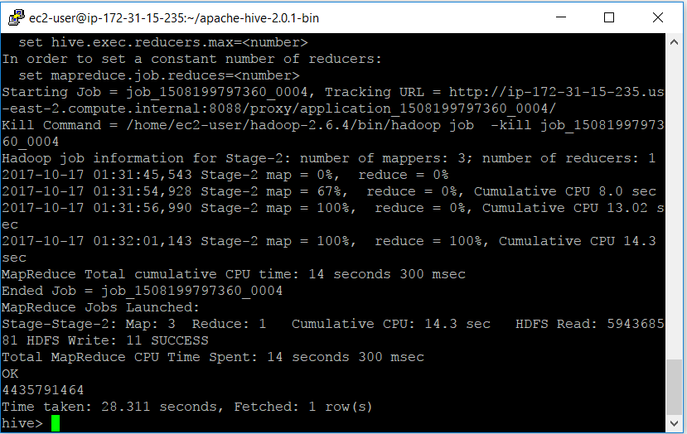

The run time is 28.311 seconds.

**2.1**

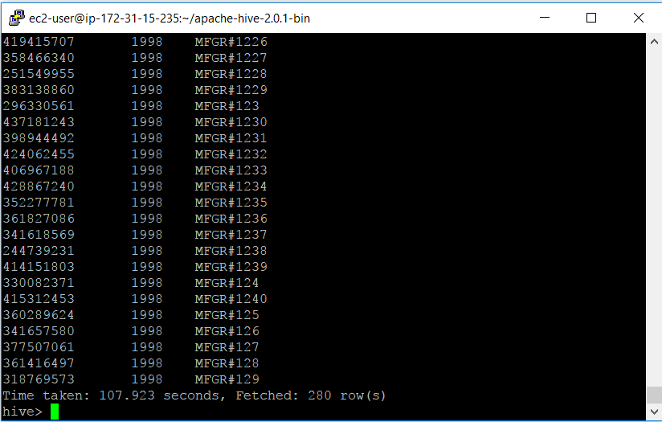

The run time is 107.923 seconds.

**2.2**

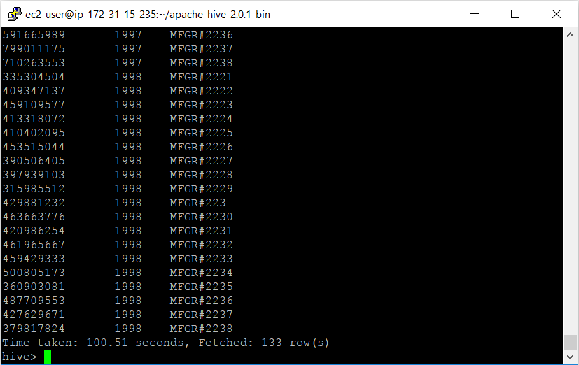

The run time is 100.51 seconds.

**Part 3**

**0.1**

LineorderData = LOAD '/user/ec2-user/lineorder.tbl' USING PigStorage('|')

AS(lo_orderkey:INT, lo_linenumber:INT, lo_custkey:INT, lo_partkey:INT, lo_suppkey:INT, lo_orderdate:INT, lo_orderpriority:CHARARRAY, lo_shippriority:CHARARRAY, lo_quantity:INT, lo_extendedprice:INT, lo_ordertotalprice:INT, lo_discount:INT, lo_revenue:INT, lo_supplycost:INT, lo_tax:INT, lo_commitdate:INT, lo_shipmode:CHARARRAY);

LineorderG = GROUP LineorderData ALL;

AvgR = FOREACH LineorderG GENERATE AVG(LineorderData.lo_revenue);

DUMP AvgR;

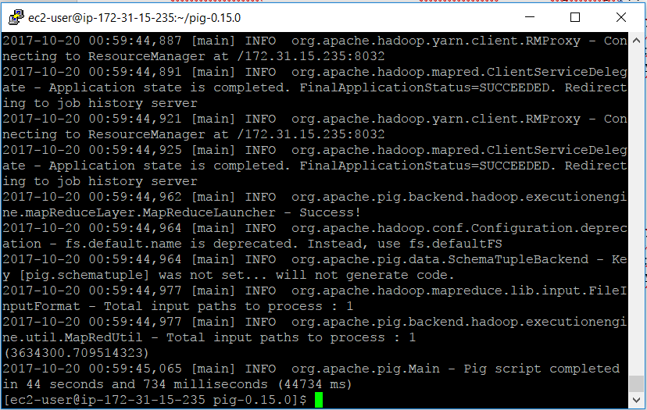

The run time is 44 seconds and 734 milliseconds.

**0.2**

LineorderData = LOAD '/user/ec2-user/lineorder.tbl' USING PigStorage('|')

AS(lo_orderkey:INT, lo_linenumber:INT, lo_custkey:INT, lo_partkey:INT, lo_suppkey:INT, lo_orderdate:INT, lo_orderpriority:CHARARRAY, lo_shippriority:CHARARRAY, lo_quantity:INT, lo_extendedprice:INT, lo_ordertotalprice:INT, lo_discount:INT, lo_revenue:INT, lo_supplycost:INT, lo_tax:INT, lo_commitdate:INT, lo_shipmode:CHARARRAY);

LineorderG = GROUP LineorderData BY lo_discount;

SetD = FOREACH LineorderG GENERATE LineorderData.lo_discount, COUNT(LineorderData.lo_extendedprice);

DUMP SetD;

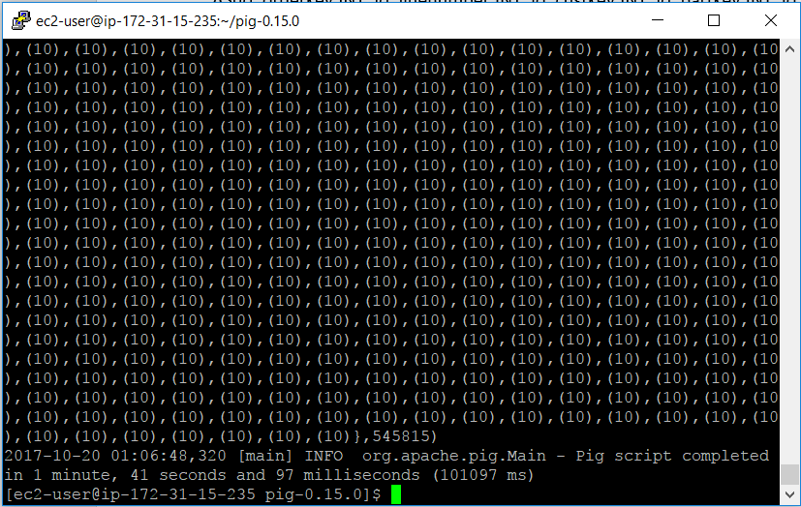

The run time is 1 minute, 41 seconds and 97 milliseconds.

**0.3**

LineorderData = LOAD '/user/ec2-user/lineorder.tbl' USING PigStorage('|')

AS(lo_orderkey:INT, lo_linenumber:INT, lo_custkey:INT, lo_partkey:INT, lo_suppkey:INT, lo_orderdate:INT, lo_orderpriority:CHARARRAY, lo_shippriority:CHARARRAY, lo_quantity:INT, lo_extendedprice:INT, lo_ordertotalprice:INT, lo_discount:INT, lo_revenue:INT, lo_supplycost:INT, lo_tax:INT, lo_commitdate:INT, lo_shipmode:CHARARRAY);

Discount3 = FILTER LineorderData BY lo_discount < 3;

DiscountG = GROUP Discount3 BY lo_quantity;

SetD3 = FOREACH DiscountG GENERATE Discount3.lo_quantity, SUM(Discount3.lo_revenue);

DUMP SetD3;

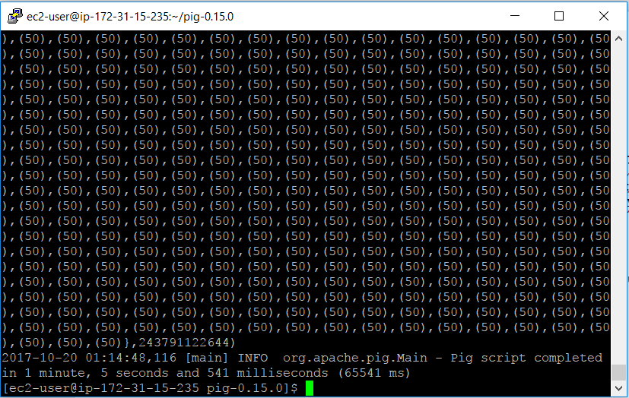

The run time is 1 minute, 5 seconds and 541 milliseconds.

**Part 4**

Mapper.py

#!/usr/bin/python

import sys

for line in sys.stdin:

line = line.strip()

val = line.split("|")

lo_quantity = val[8]

lo_revenue = val[12]

lo_discount = val[11]

print '%s\t%s\t%s' % (lo_quantity, lo_revenue, lo_discount)

Reducer.py

#!/usr/bin/python

import sys

lo_dic = {}

lo_list = []

sum_rev = 0;

for line in sys.stdin:

line = line.strip()

lo_quantity, lo_revenue, lo_discount = line.split("\t")

if int(lo_discount) < 3:

if lo_quantity in lo_list:

lo_dic[lo_quantity].append(int(lo_revenue))

else

lo_list.append(lo_quantity)

lo_dic[lo_quantity] = []

lo_dic[lo_quantity].append(int(lo_revenue))

for keys, values in lo_dic.iteritems():

if keys in lo_list:

sum_rev = sum_rev + sum(values)

print '%s' % (sum_rev)